**PRODUCT SPECIFICATION**

**PRELIMINARY DESIGN**

**TEAM 2**

**Ekim Kurtulmaz**

**Kaan Denizer**

**Serkan Atrek**

**Gökhan Toker**

**Mehmet İveynat**

Date: 9.11.10

**PRODUCT SPECIFICATION**

1. **Camera (Microsoft Liftetime Cinema Webcam H5D-00001)** 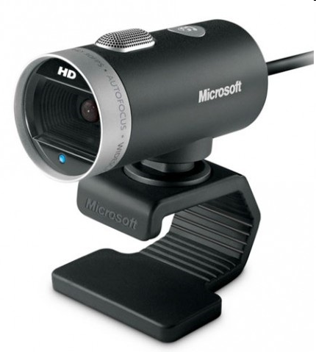

**Figure 1 : Microsoft Liftetime Cinema Webcam H5D-00001**

**Specifications :**

LifeCam Cinema full-featured webcam, with ClearFrame image-processing technology, delivers smooth, detailed video and crystal-clear audio. Digital, noise-canceling microphone helps improve speech quality. 720p sensor captures true HD quality video at up to 30 fps.(1)

|  |  |  |
| --- | --- | --- |
| **Video Resolution** |  | : 1280 x 720 @ 30 fps |

|  |  |  |
| --- | --- | --- |
| **Interfaces/Ports** |  | 1 x USB 2.0 USB |

|  |  |  |  |
| --- | --- | --- | --- |
|  | **System Requirements** |  | • Windows 7, Windows Vista, Windows XP with Service Pack 2 (SP2) or higher  • Minimum:Intel Dual-Core, 1.6 GHz or higher, 1 GB of RAM  • Recommended: Intel Dual-Core 3.0 GHz or higher, 2 GB of RAM, 1.5 GB free CD-ROM  • USB 2.0  • Windows-compatible speakers or headphones |

**Power Consumption :**

Operating voltage : 5 Vdc

Maximumum Current : 500 – 900 mA

**2) Board Marker(Red for writing ,Green for erasing.)**

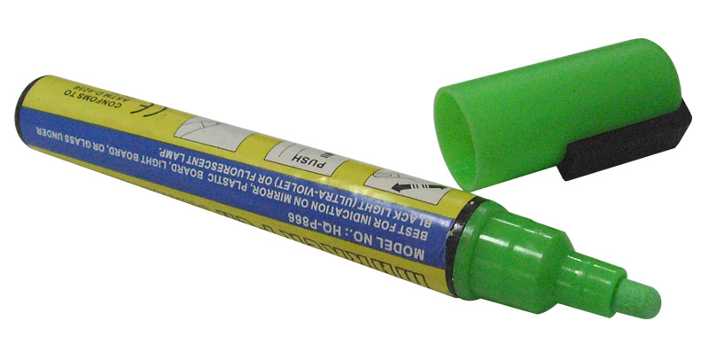

**Figure 2 : Colored Board Marker**

A board marker which has been paint with distinct color like red or green will be used. It will have the dimensions of a regular board marker. A cylinder with height of 10 cm and radius of 1cm.

**PRELIMINARY DESIGN**

**Block Diagram**

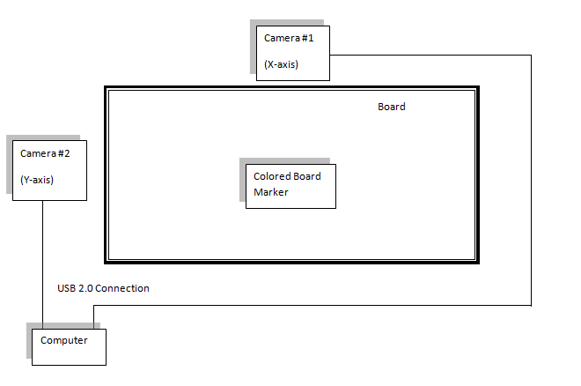

**Figure 3 : Block Diagram**

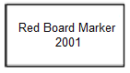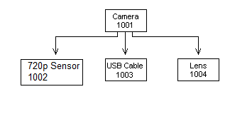

**Figure 4 : Product Tree**

Main idea of our system is to capture the movement of the red colored board marker, which has 10 cm length and 0.5 cm radius, on a regular board (height is 1 meter, length is 2 meters and depth is 2 centimeters) and save these movements as avi video format in a computer. According to our design, two Microsoft Liftetime Cinema Webcam H5D-00001 cameras (one camera for each axis) that are placed up and right edges of a board will catch the motion of the certain axis movements of a colored board marker and send images simultaneously to the computer by USB 2.0 ports.   Then the vidoes will be digitally processed as images by the C++ algorithm that we create so we can find the location of the colored board marker by using a software program. To do these image processing operations, we are using opencv library. The algorithm will detect the red colored pencil. By using these, we will determine x and y axis of the board marker according to a virtual origin on the board. This data will be used to draw what is on the board pixel by pixel. To manage the drawing action on computer, we plan to create our own drawing program with C++ since communication with “Paint” may cause some problems.

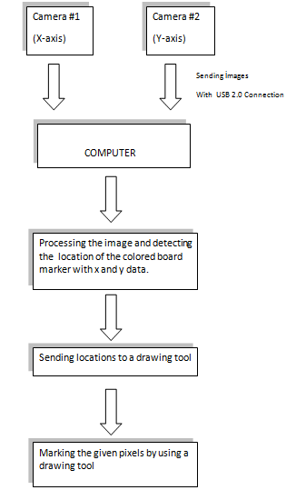

**Figure 5: Flow Chart**

**User Interface**

User will interact with the system by using a computer program. This program will have the writings and shapes on the board and will show it to the user.

References

1. http://www.shopping.hp.com/webapp/shopping/product_detail.do?product_code=BU1402&aoid=8023&srccode=cii_13736960&cpncode=21-85040833-2
2. http://www.buy.com/prod/microsoft-lifecam-cinema-hd-webcam/q/loc/111/211504645.html
3. http://www.uruninceleme.com/?p=1811
4. http://www.thorlabs.de/thorProduct.cfm?partNumber=DCU223C
5. http://www.adept.net.au/cameras/highColour.shtml
6. http://www.howtofixcomputers.com/bb/ftopic197589.html
7. http://www.buy.com/prod/microsoft-lifecam-cinema-hd-webcam/q/loc/111/211504645.html
8. http://www.shopping.hp.com/webapp/shopping/product_detail.do?product_code=BU1402&aoid=8023&srccode=cii_13736960&cpncode=20-63637498-2